Tema 3+4 Baze de date

Stanescu Maria_Raluca

Grupa 132

1. SELECT e1.last_name as nume_smr, e1.department_id as id_departament_smr, e1.salary as salariu_smr, e1.job_id as id_job_smr

FROM employees e1

WHERE (commission_pct, salary) IN //conditia ca angajatii din orice oras sa aiba acelasi salariu si //comision ca un angajat din oxford

(SELECT commission_pct, salary //tabel cu perechile de salariu si comision ale salariatilor din Oxford

FROM employees e

JOIN departments d ON (e.department_id = d.department_id)

JOIN locations l ON (l.location_id = d.location_id)

WHERE lower(l.city)='oxford'); //lower pt indeplinirea conditiei no case sensitive

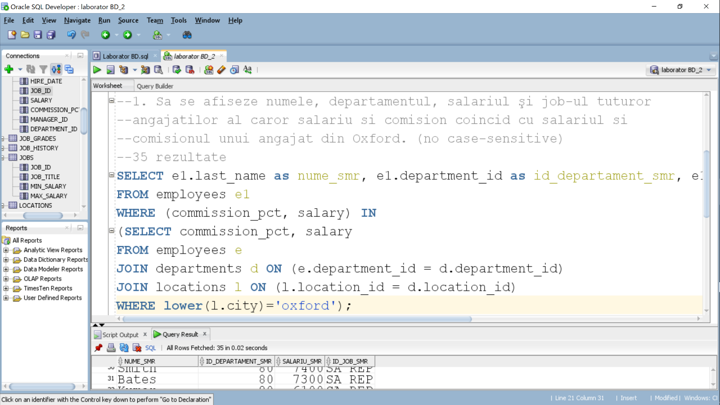

2. SELECT e.last_name as nume_smr,e.first_name as prenume_smr, e.salary as salariu_smr, e.department_id as departament_smr

FROM employees e

WHERE salary>(SELECT MIN(AVG(SALARY)) //conditia pt salariul angajatului > minimul mediei salariului //pe joburi

FROM employees

GROUP BY job_id); //group by job id pt gruparea salariilor pe joburi

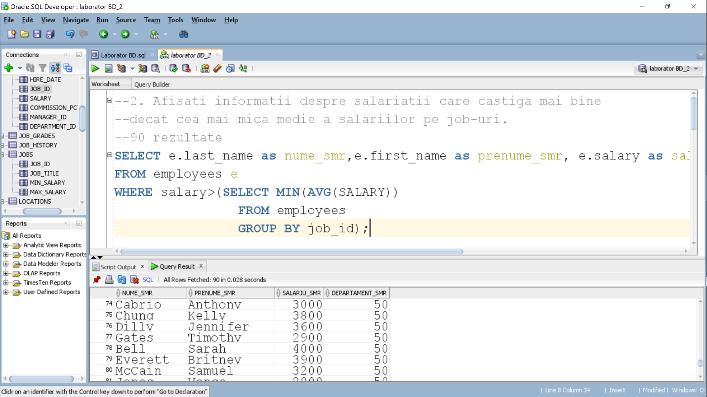

3. select e.last_name as Nume_smr, e.salary as salariu_smr, j.job_title as numejob_smr

from (select job_id, avg(salary) salary

from employees

group by job_id) aux, //folosim goup by pt indeplinirea conditiei de „pt fiecare job”+construim //tabelul auxiliar pentru a pastra media reala a salariului pt fiecare job

employees e, jobs j

where e.job_id = aux.job_id

and j.job_id = aux.job_id //conditiile pt selectarea angajatilor cu acelasi job

and e.salary > aux.salary; //conditia pt salariu mai mare decat media reala pt fiecare job

